

Approved by the National Institute of Health: <https://3dprint.nih.gov/discover/3dpx-013306>

Nozzle Size: 0.4 mm Layer Height: 0.2 mm Material: PLA

Direct site for 3DVerkstan Face Shield: <https://3dverkstan.se/>

To assemble, attach the center holes first, then the outer sides. It should be a nice tight fit.

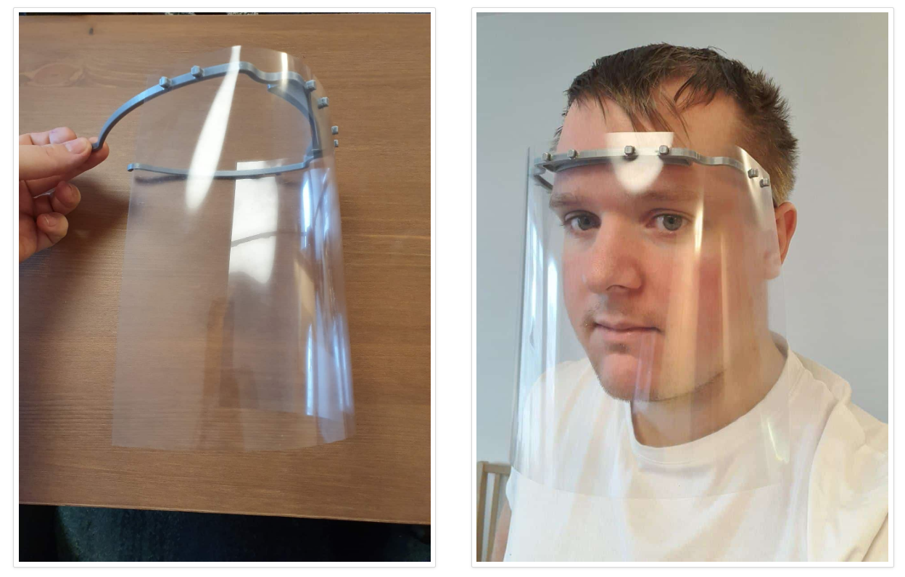



To Whom It May Concern:

While we undertake measures to help ensure the PPE we provide to you is safe and effective,

we do not and can not make any guarantees to that effect. This PPE is provided as is and we

expect that the recipient has the familiarity and opportunity to inspect its suitability for their

intended use. BASED ON SUCH INSPECTION, YOU ACCEPT THIS EQUIPMENT "AS IS"

WITH NO REPRESENTATIONS OR WARRANTIES, EITHER EXPRESS OR IMPLIED,

INCLUDING WITHOUT LIMITATION, ANY IMPLIED WARRANTIES OR FITNESS FOR A

PARTICULAR PURPOSE.

If you have questions, please contact info@masksfordocs.com.

MasksForDocs.com